ASSIGNMENT 3
Name : SHASHWATH S SHETTY
Class : 3C
USN : ENG25CY3003
DATE : 27/09/2025

1. Distinguish between man and whatis commands? Justify with proper example.
Soln:
man command :
The man command displays manual pages.
Syntax: man [options] command

Whatis command :
Gives a one-line short description.

Example: whatis ls → “ls (1) – list directory contents”.

2. Use the tee command to save the output of ls -l into a file while also displaying it.
Soln: 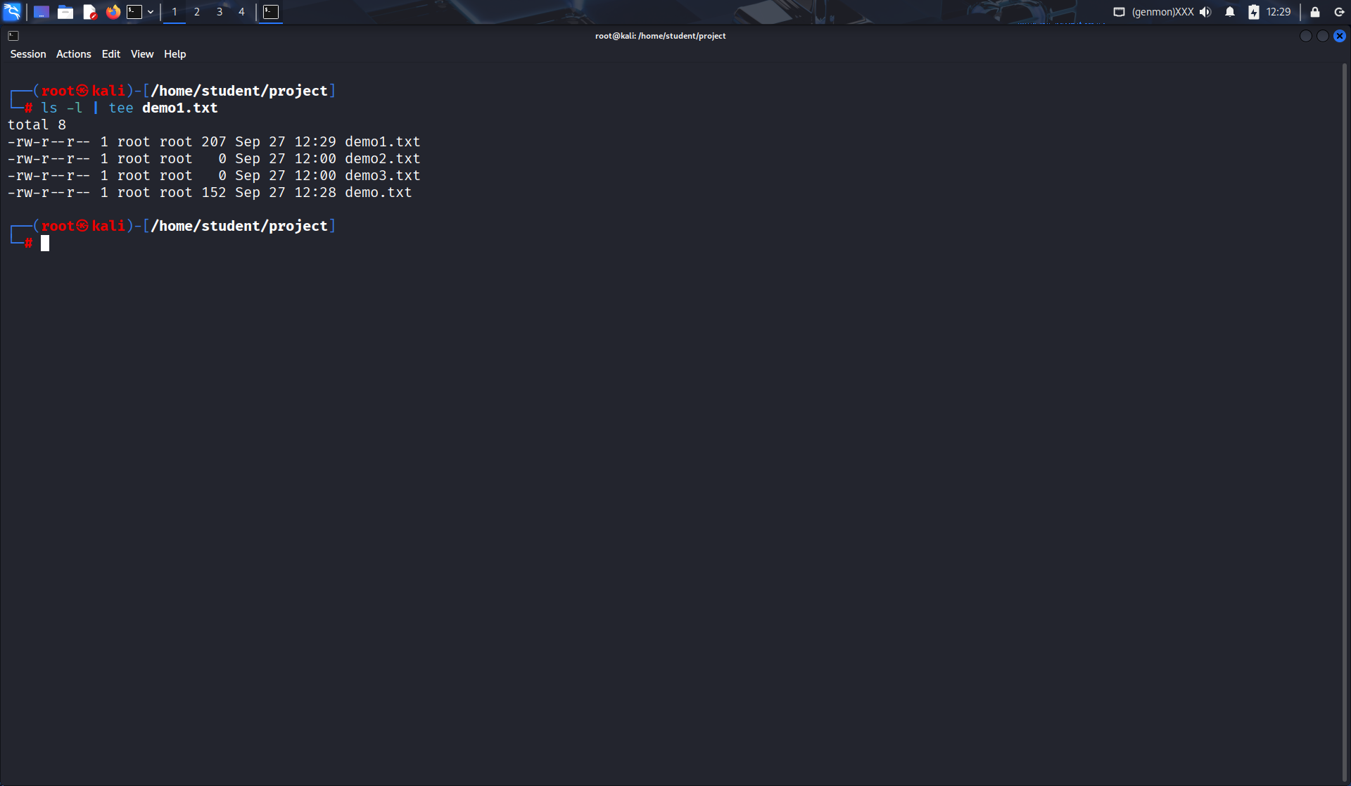

3. Explain with an example how the tee command can be used in logging.
Soln: 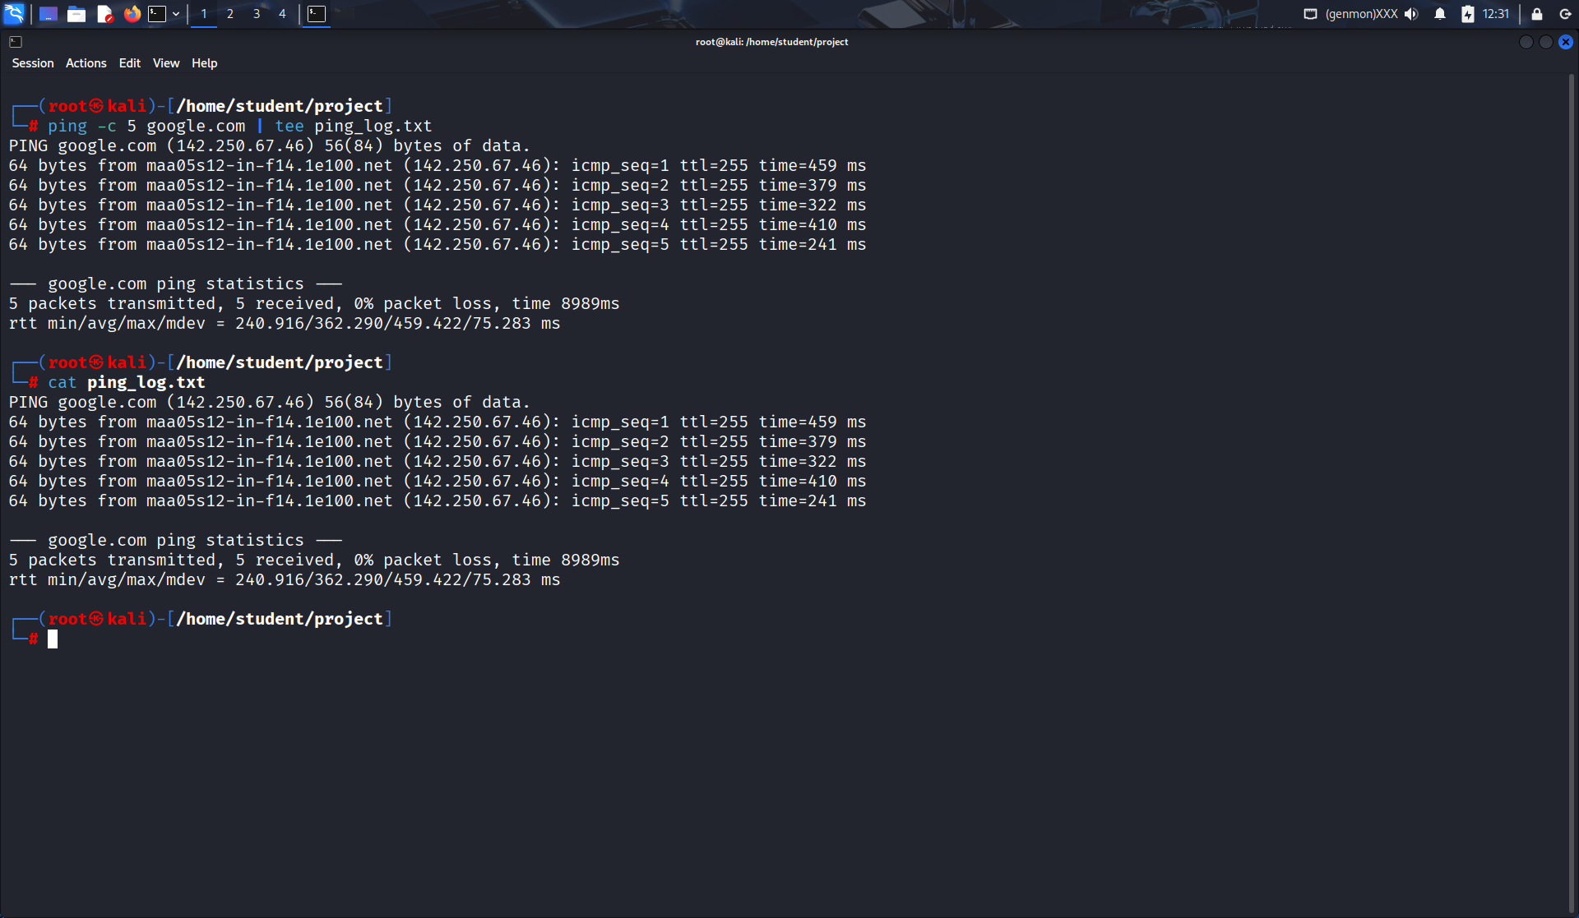

4. List the steps involved in installing Ubuntu 25.04 LTS on Oracle VirtualBox.
Soln:

• Download ISO of Ubuntu 25.04 LTS.
• Install and open Oracle VirtualBox.
• Click New VM → Name: Ubuntu25.04.
• Allocate RAM (at least 2–4 GB) and storage (20 GB+).
• Attach ISO file as virtual optical disk.
• Start VM → Boot from ISO → Select “Install Ubuntu”.
• Follow installation wizard (language, keyboard, partition, user).
• Finish setup and restart VM.
5. During Ubuntu OS installation, you face a Kernel Panic Error. How would you troubleshoot it?
Soln:
• Check ISO integrity (verify checksum).
• Allocate enough RAM/CPU in VirtualBox.
• Enable VT-x/AMD-V in BIOS.
• Use “Safe graphics mode” in installer.
• Update VirtualBox to latest version.
6. Write the command to display the system’s hostname? How to change hostname using sysctl command?
Soln: 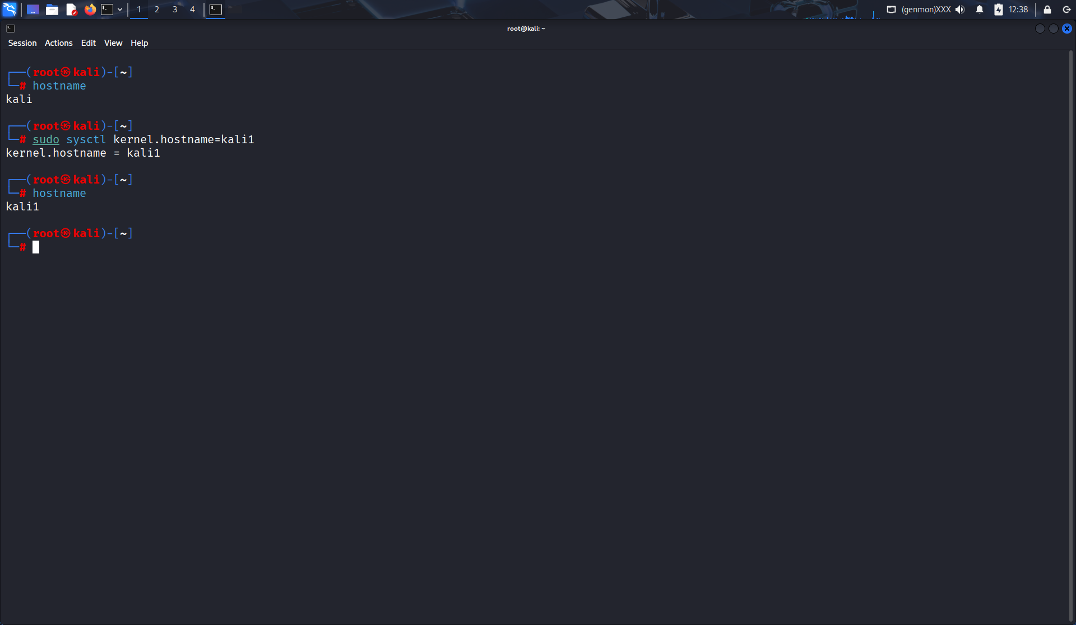

7. Which command is used to show the calendar of the year 1984 with August month?
Soln: 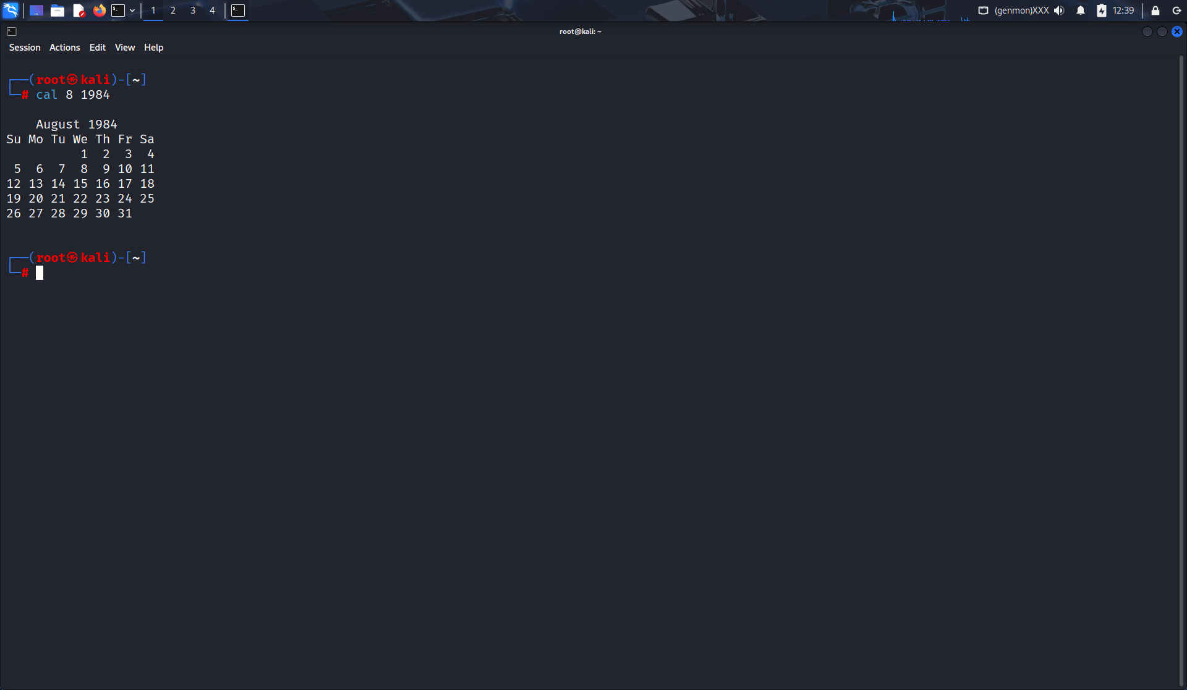

8. Write a command to display system uptime and logged-in users together.
Soln: 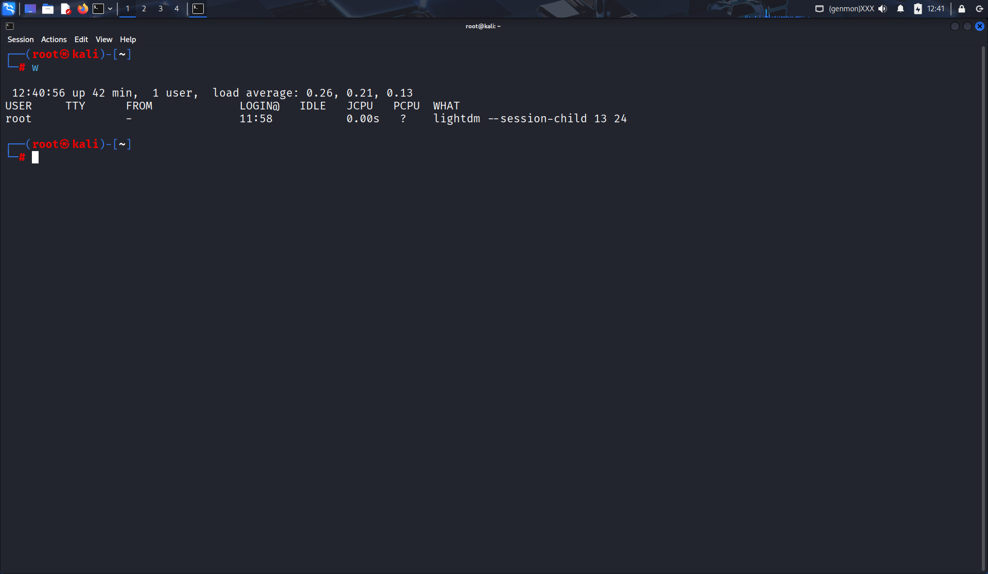

9. Use the find command to list all “.c” files in /home/user
Soln: 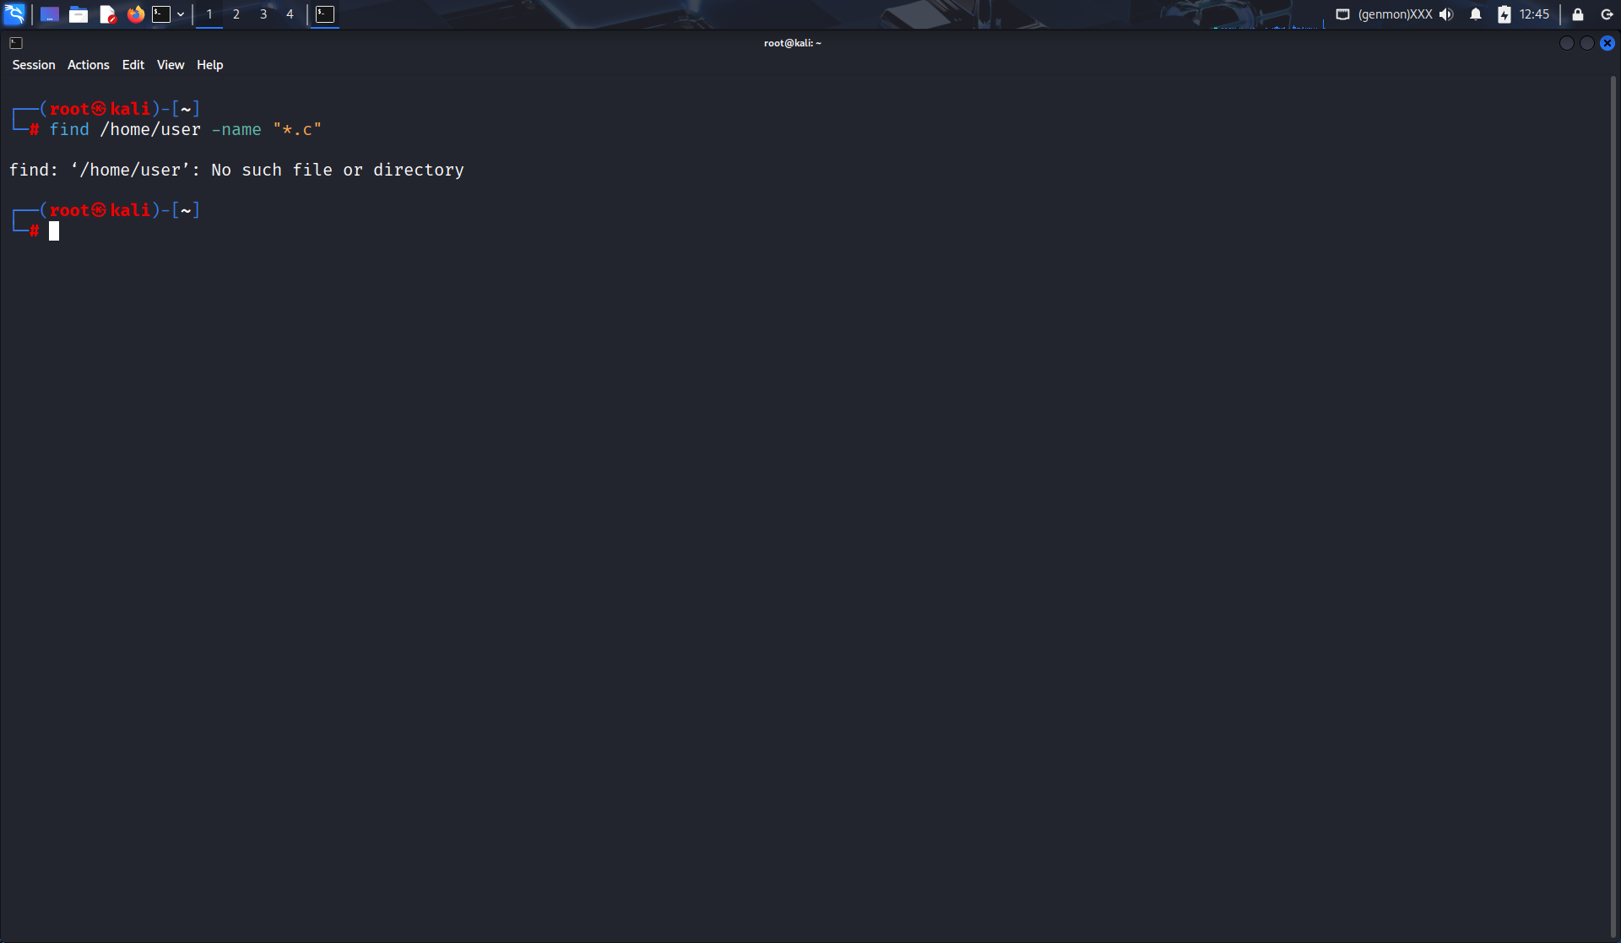

10. How do you change file permissions to allow only the owner to read and write?
Soln:
chmod 600{ filename}

